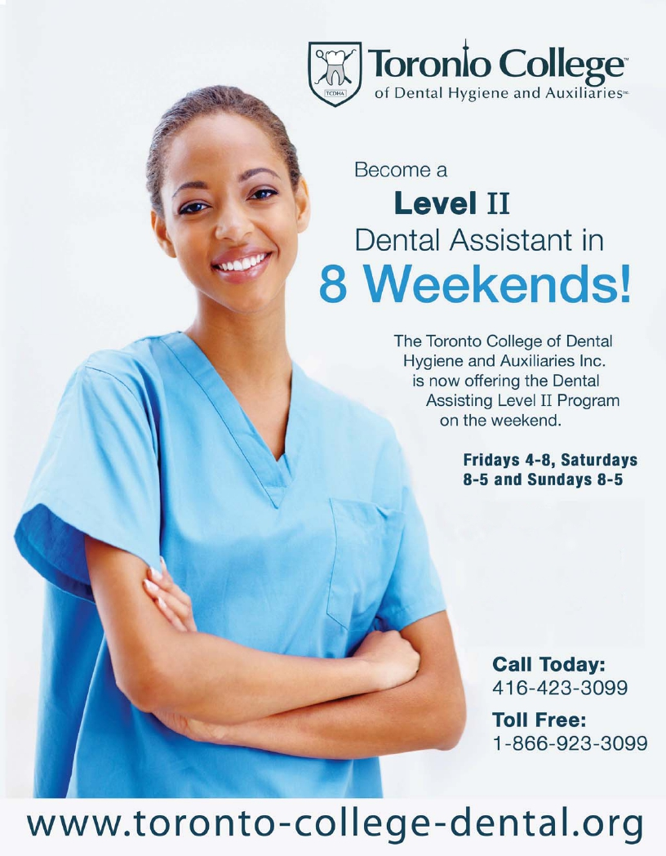


Dear Applicant,

Thank you for your interest in Toronto College of Dental Hygiene and
Auxiliaries Inc.

The information regarding our Dental Assisting Level II Program is attached.
Please complete the application form in full, and mail it to TCDHA, e-mail it to info@toronto-college-dental.org or fax it to 416-423-3092.

At the Toronto College of Dental Hygiene and Auxiliaries Inc. our goal is
to put your needs and your career success first.

Whether you are applying from within the city, the province, Canada or internationally, our friendly admission staff will assist and guide you throughout the entire admission process.

We look forward to speaking with you in the near future about attending the Toronto College of Dental Hygiene and Auxiliaries Inc.

If you require further information or assistance, please visit our webpage at
http://www.toronto-college-dental.org or to speak with us directly, please
contact us at (416) 423-3099 or toll free at 1-866-923-3099.

Sincerely,

Admissions Coordinator,
Toronto College of Dental Hygiene and Auxiliaries Inc.
College Information

The Toronto College of Dental Hygiene and Auxiliaries (TCDHA) is owned and operated by a Registered Dental Hygienist and a Licensed in Ontario.
The College is unique in the sense that the sole focus of the Institution is based on providing High Levels of Current Dental Education.
The Dental Assisting Level II Program will also provide the skills necessary for the graduate to explain and discuss the various treatment options with the patients/clients. This program will provide the students with all the skills necessary to perform all of the Dental Assisting Level II clinical requirements.
The Toronto College of Dental Hygiene and Auxiliaries Inc. is located at 28 Vanley Crescent. The campus has 69 dental chairs, 14 of which include digital radiography rooms. There are also five large classrooms, a computer lab, a dental materials lab, library, locker area and lunch area.
The Dental Assisting Level II Program is 8 weekends long.
Classes are held on Friday evening from 4pm -8pm
Saturday from 8am -5pm
Sunday from 8am -5pm
History of the Toronto College of Dental Hygine and Auxiliaries Inc.

The Toronto College of Dental Hygiene and Auxiliaries Inc. (TCDHA) was
founded by and is still operated by a licensed dentist and a registered dental hygienist in Ontario. The Dental Hygiene Program at TCDHA commenced in January 2004.

TCDHA is approved under the Private Career Colleges Act, 2005 and registered under the Private Career Colleges Act, 2005.

DIRECTIONS

Directions from Highway 401:

Take exit 365 for Allen Road North. Turn left on to Sheppard Ave West. Drive 600 metres and take a right onto Chessword Dr. Turn right onto Vanley Crescent and TCDHA is located on the left-hand side.

Directions from Highway 400:

Exit on the Finch Ave. ramp and head east to Chesswood Dr. Turn right onto
Chesswood and then left on Vanley Crescent. TCDHA is located on the right-hand side.

Public Transit from Downsview Station:

- Take the 107B bus. Exit on Chesswood Dr. at Vanley Crescent. Walk 2 minutes down Vanley Dr. to TCDHA.

- Take either the 84 Sheppard West (westbound), 108 Sheppard
West, or 106 Sheppard West bus. Exit at Chesswood Dr. and walk north to Vanley Dr. Turn right on Vanley Dr. and walk 2 minutes to TCDHA

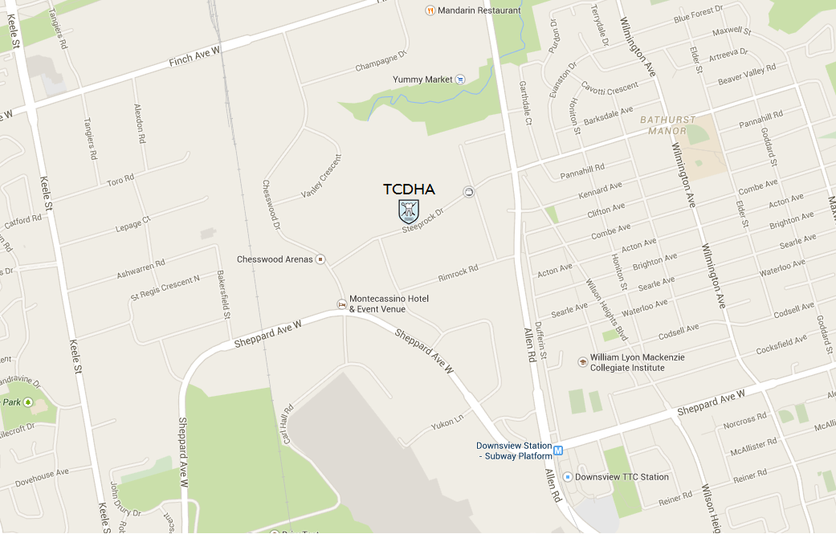

We encourage all applicants who are interested in the Dental Assisting Level II Program at TCDHA to please read the comprehensive admission information within this package. Applicants that have specific questions or would like additional information regarding the Dental Assisting Level II Program should call the admissions department at 416-423-3099 or 1-866-923-3099 (toll free in North America).

Entrance Requirements

All applicants must have proof that they have successfully completed a Dental Assisting Level I Program. A copy of their transcript and or Diploma is required to be submitted.
All applicants must call the College to schedule a time to attend a Dental Assisting Level II meeting to discuss the entry requirements
There is no fee for the Dental Assisting Level II entrance meeting.
The Student application form must be completed prior to the meeting and either mailed or brought to:
Toronto College of Dental Hygiene and Auxiliaries Inc.
300 Steeprock Drive
Toronto, Ontario
M3J 2W9
Monday – Thursday 8:00 am to7:30 pm or Fridays 8:00 am to 4:30pm.
International Applicants
TCDHA accepts international students if they meet all the entry requirements. TCDHA is designated by the International Student Program (ISP) as a Designated Learning Institution with Citizenship and Immigration Canada (CIC)
Successfully completing the Dental Assisting Level II Program at TCDHA does not guarantee the ability to work and/or to live in Canada. Please see the Citizenship and Immigration Canada (CIC) website for information on studying, working and living in Canada.
English Proficiency
English is the language in which the Dental Assisting Level II Program is taught at the Toronto College of Dental Hygiene and Auxiliaries Inc.
TCDHA does not teach English as a second language to the students.
Prior Learning Assessment
Applicants of the Dental Assisting Level II Program with a dental background or other related courses will not be granted advanced standings or exemptions for courses taken elsewhere.
All courses must be taken and completed successfully in order to graduate from the program offered at TCDHA.
Recommended Personal Admission Requirements
- Good vision and visual perception with or without corrective lenses.
- Manual dexterity that allows manipulation of small instruments with repetitive motions.
- Good interpersonal communications skills.
- Confidence speaking in front of individuals and/or groups.
- Problem solving and critical thinking skills.
- Emotional maturity with an internal value of helping and caring for others.
- Ability to co-operate with others.
- Ability to handle responsibility.
- Self-motivation.
- Good organizational skills and time management skills.
- Attention to detail.
Conditional Acceptance Status
A qualified applicant will be offered conditional acceptance into the program. There are documents and payment requirements that must be met prior to the qualified applicant being offered full acceptance into the program.
Once the applicant is offered “Conditional Acceptance” they will be given a set period of time to respond to the College if they wish to accept the offer.

Once the candidate has accepted the “Conditional Acceptance” offer they will be sent requirements and documents that need to be read, signed and return within a specified period of time.

In addition the qualified applicant must provide evidence of their status in Canada by providing a copy of one of the following documents:
- Canadian Passport;
- Canadian Citizenship Card;
- Canadian Birth Certificate;
- Documentation of Permanent Residence Status;
- Documents of Landed Immigration Status; or
- Documentation of Study Visa*
*Study Visa must be valid in Canada – for the duration of the program

Additional documents that must be submitted prior to the start of the program are as follows:

- Proof of current Cardio-Pulmonary Resuscitation (CPR)
LEVEL C Certificate
- Immunization Form provided by TCDHA completed
- Criminal Record Check (CPIC) and Vulnerable Sector Screening (VSS)*
Applicants that live in Toronto will need to pick up a form from the Admissions Office prior to going to the police station. Please contact TCDHA for more information.
Note:
Any fees associated with completing these documents are the responsibility of the applicant.

Full Acceptance Status
Full Acceptance Status into the Dental Assisting Level II Program at the Toronto College of Dental Hygiene and Auxiliaries Inc. is granted once the qualified applicant has signed the Student Enrolment Contract and completed all the entrance requirements stated in the “Conditional Acceptance” offer. This includes any required payments prior to the commencement of the program.
Waiting List
A waiting list of qualified applicants will be established any time that the number of qualified applicants exceeds the program’s capacity.
These qualified applicants will receive an e-mail or telephone call informing them that they have been placed on the program wait list.
Each qualified applicant will be informed and assigned a number indicating their actual position on this wait list (e.g. “1” would indicate that the individual has first priority if a seat becomes available). The number will be assigned according to the date the applicant is deemed qualified.
Qualified applicants that are still on the wait list once the available spaces have been filled and the selection process is complete, would receive an e-mail indicating that they will not be admitted to the program. Qualified applicants would be permitted to have their application forwarded to the next available intake.
Closing of Program
Entry into the program will be deemed closed when all the available seats are filled. Qualified applicants on the wait list will be notified that the program is full.
Career Opportunities
Dental Assisting is a dynamic and challenging health care profession which allows for a wide range of opportunities. Dental Assisting is desirable due to its flexible hours. There are options for part-time or full-time career opportunities.

TCDHA does not guarantee employment for any student who successfully completes the Dental Assisting Level II Program.

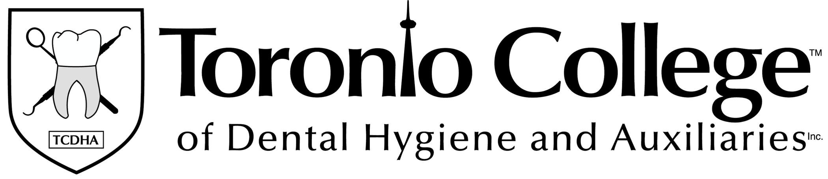
Program Fees

The Toronto College of Dental Hygiene and Auxiliaries Inc. anticipated fees for the Dental Assisting Level II Program are as follows:
Tuition: $3,090.00
Additional Fees:
Books: $200.00
Uniforms and Equipment $15.00
Expendable Materials $610.00

Total for Dental Assisting Level II Program $3,915.00
*Book fees may be subject to change due to price increases by book publishers.

Students enrolled in the Dental Assisting Level II Program may be eligible, for loans, grants, or awards granted under the Ontario Students Assistance Program (OSAP). The OSAP website is as follows: https://osap.gov.on.ca/OSAPPortal

The National Student Loans Service Centre address is as follows:
P.O. Box 4030, Mississauga, Ontario L5A 4M4

COMMON QUESTIONS AND ANSWERS

Is the Dental Assisting Level II Program registered with the Ministry of Training, Colleges and Universities (MTCU)?
The Dental Assisting Level II Program is approved under the Private Career Colleges Act, 2005.
The Dental Assisting Level II Program is registered under the Private Career Colleges Act, 2005.

Do students receive a certificate or a diploma once they complete the program at the TCDHA?
Upon successfully completion of the Dental Assisting Level II Program offered at the TCDHA, the student will receive an official diploma.

How long is the Dental Assisting Level II Program offered at TCDHA?
The Dental Hygiene Program offered at TCDHA is 8 weekends or approximately 2 months in duration. Students are able to complete the program in approximately 2 months because TCDHA does not take breaks.

What is the cost of the program offered at the TCDHA?
The total program cost is $3,915.00. This includes everything from tuition, textbooks and materials.

Are there any hidden fees that we should be aware of at the TCDHA?
NO! There are no hidden fees. TCDHA believes that the student should know what their financial situation is well in advance so that they can prepare themselves for the financial commitment of the Dental Assisting Level II Program.

Does TCDHA have payment options?
YES! TCDHA accepts monthly payments as an option to assist students with
their finances during the program.

Are there other programs that TCDHA accepts for payment?
YES! The Second Career Program is another payment option.
Native Status in Canada is also a payment option.

Does TCDHA assist students with bank loans or line of credit applications?
YES! There are several financial institutions that will assist students with student loans and student lines of credit. Most financial institutions will require a co-signer when applying for a student loan or line of credit.

TCDHA Admissions Coordinators assist applicants with all of the financial options that are available. They can be reached at 416-423-3099 or toll free at 1-866-923-3099.

Does the Dental Assisting Level II Program accept out of province students?
Yes! TCDHA accepts students from all across Canada. TCDHA understands
that there is a lot of planning involved with attending the Dental Assisting Level II Program away from home. The admission staff will assist the applicant throughout the entire process until arrival at TCDHA.

Does the Dental Assisting Level II Program accept International students?
Yes! TCDHA accepts international students if they meet all the entry requirements. Toronto College of Dental Hygiene and Auxiliaries Inc. is designated with the International Student Program (ISP) as a Designated Learning Institution with Citizenship and Immigration Canada (CIC)
Successfully completing the Dental Assisting Level II Program at the Toronto College of Dental Hygiene and Auxiliaries Inc. does not guarantee the ability to work and/or to live in Canada. Please see the Citizenship and Immigration Canada (CIC) website for information on working and living in Canada.
Study visas must be valid in Canada for the duration of the study period.

Does TCDHA provide employment assistance?
YES! TCDHA provides assistance with job placement in the following ways:

- TCDHA post all job openings and opportunities on the internal job posting board.
- Current students are informed of potential job opportunities through e-mails.
- TCDHA maintains alumni information and notifies former graduates of potential job opportunities through e-mail.
- TCDHA instructs students in resume writing, interview techniques, soft skills, and job preparations skills.
- TCDHA allows students to utilize the facilities to contact potential employers and print resumes.
- TCDHA may provide a letter of reference for graduates.

TCDHA does not guarantee employment for any student who successfully completes the Dental Assisting Level II Program.
Additional Information

Please visit the TCDHA website at www.toronto-college-dental.org or call
416-423-3099 or 1-866-923-3099 (toll free) to speak to an Admissions Coordinator.
It is recommended, if possible, to schedule an individual.
This can be done by contacting a TCDHA Admissions Coordinator.

Scan the application to: info@toronto-college-dental.org
Fax application to: 416-423-3092
Mail application to: TCDHA, 300 Steeprock Drive, Toronto, Ontario, M3J 2X1 Attention: Admissions Department

